Go to the Herzing University Library site:
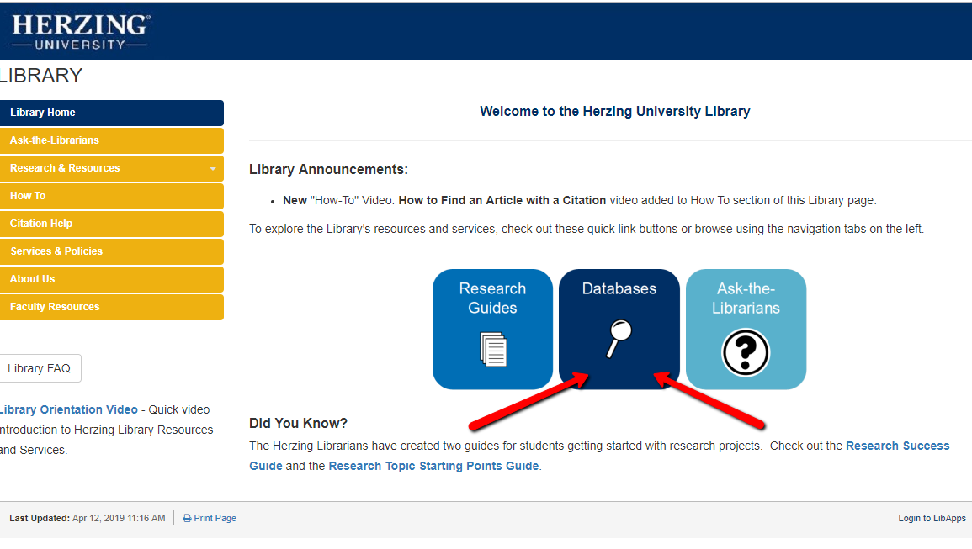
After you select Databases you will see:
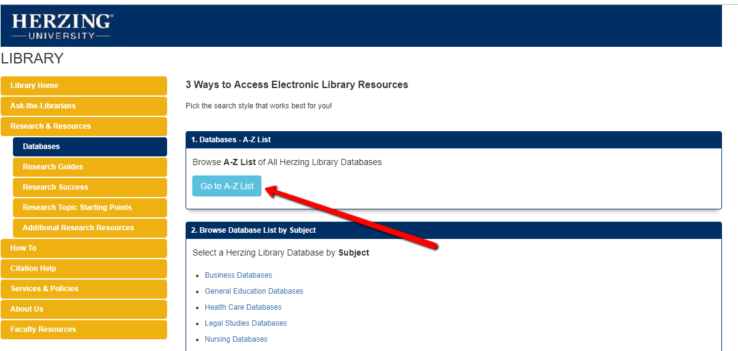
Use the A to Z list to find Business Source Complete under B.
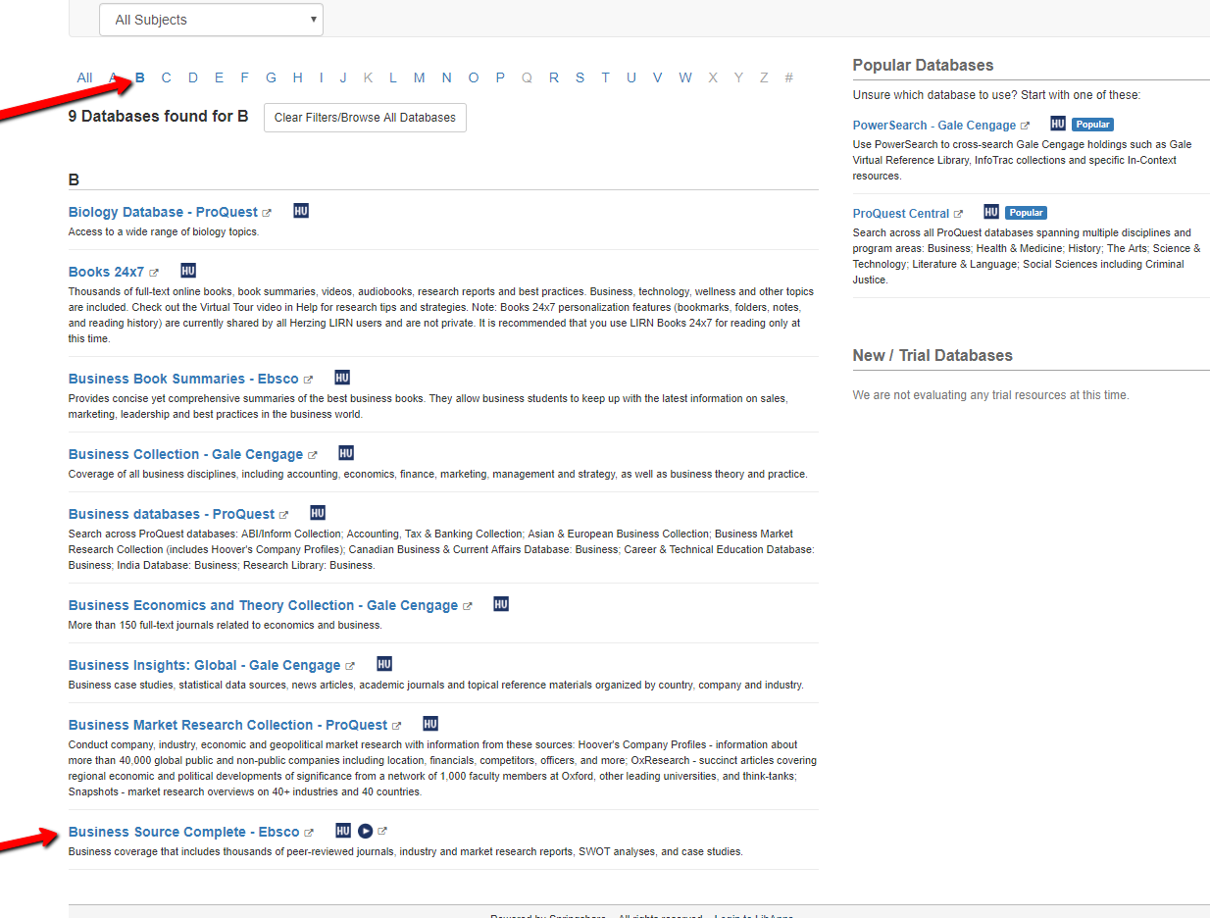
Use the A to Z list to find Proquest Central under P.
