Unit 3 Assessment B – Career Profile & Career Coach

Instructions
Each Career Coach has a Career Center Course in Canvas. This course is titled “Career Center – Career Coach Name. You are enrolled in the course belonging to the coach to which you have been assigned.
This course should be available to you in your Dashboard.
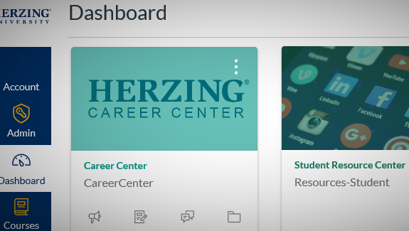

If you do not see the Career Center Course listed, scroll to the bottom of the list and select “All Courses”. You will then see a list of all the courses you are registered in.
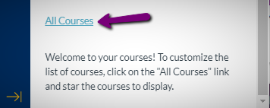

Find your Career Center course (in this case it is Rick Herian – but it may be a different name for your course). If the star is white and grey, select the star to add it to your Dashboard and Course list.
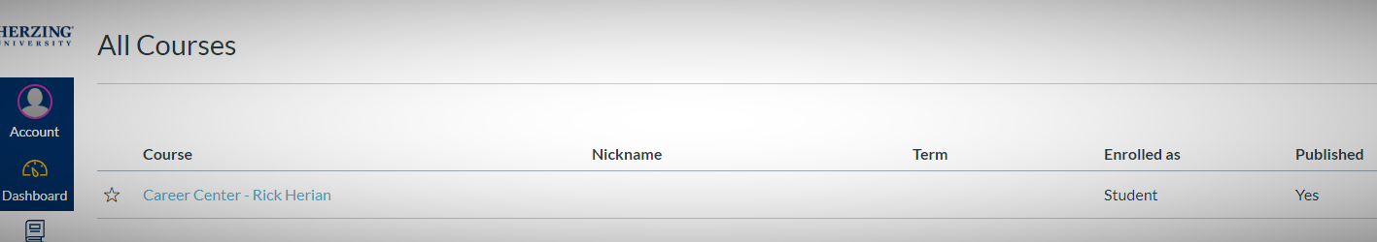

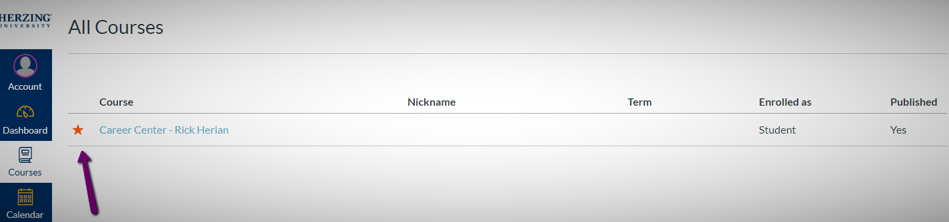

Select (click on) the course to access it.
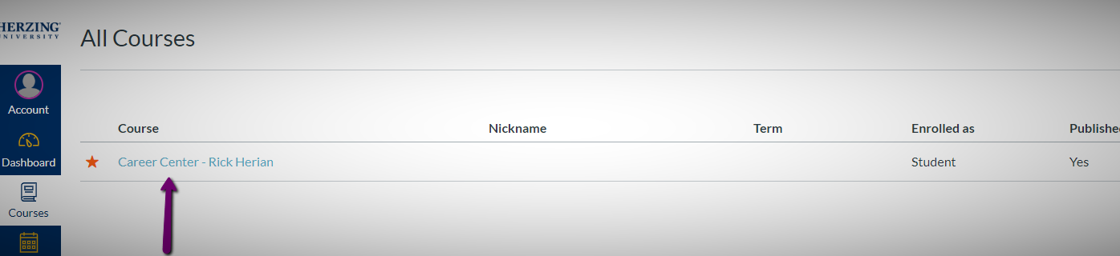

Once you are in your assigned Career Center Course, navigate to Career Center Overview
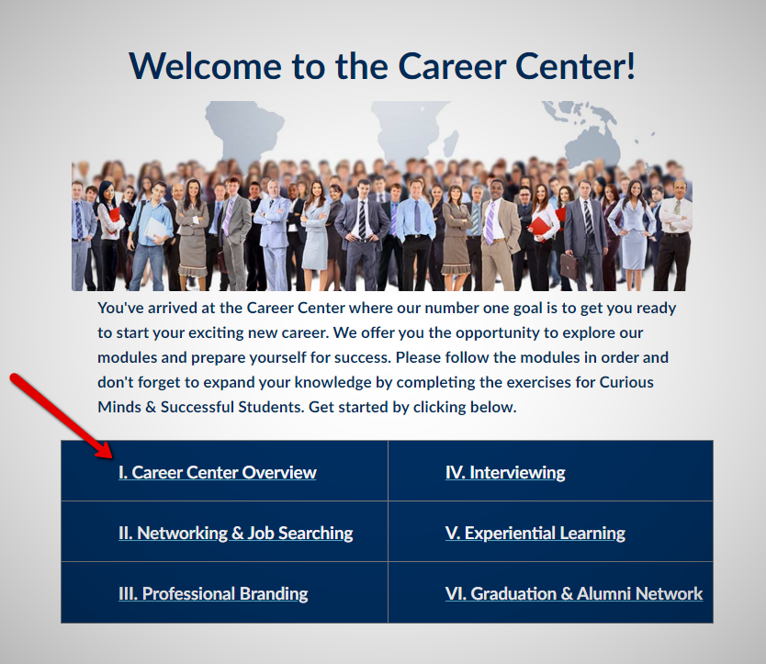

View the Career Coach Video (note the contact information below the video – and contact your coach right away (you may have already been contacted by your coach – be sure to respond as soon as possible. The sooner you begin to work with your career coach, the more successful you will be.
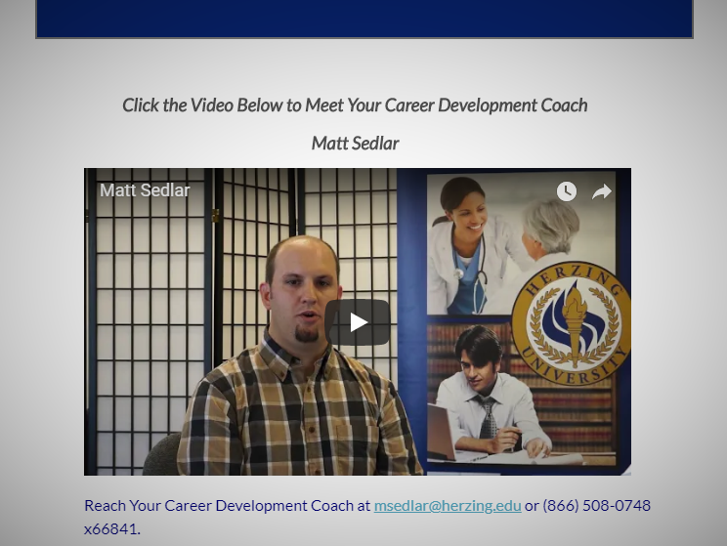

Once you have viewed the video and sent an email to your personal coach, Scroll down the page and Under 1. Let’s Begin, complete the Student Career Profile. Be sure to click Save and Continue.
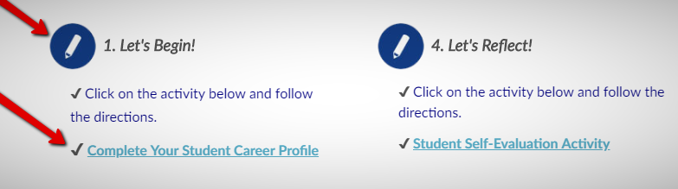

In the Toolkit, click on ePortfolio and add your headshot
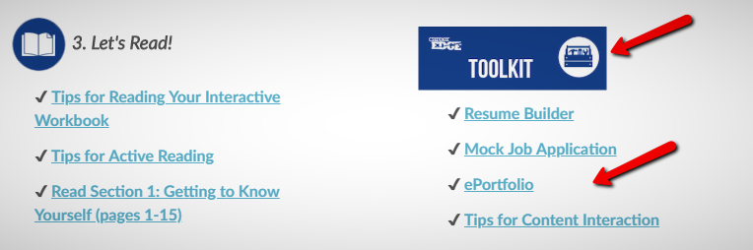
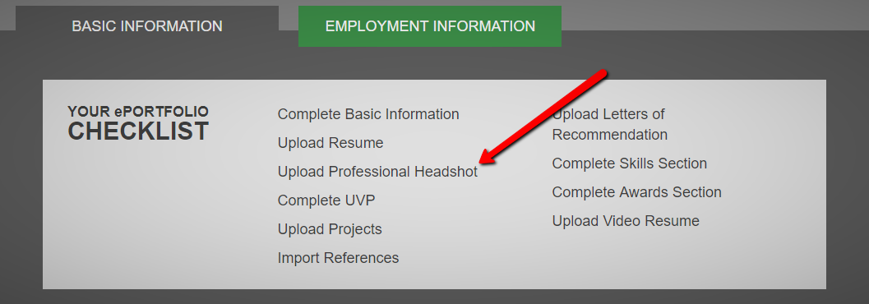

When you are done working on your portfolio and watching the video, use the browser back arrow to return to this page.
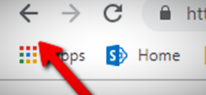

Then Complete the Following:
- How did you connect with your Career Coach Choose your connection
Note that you should schedule a time in the next 1 to 2 weeks to discuss the information you entered in your Student Career Profile, as well as to determine a schedule to connect throughout your program at Herzing University.

- Obtain Lifecycle Working Career Development from your career coach and submit it with this worksheet as your assignment. You do not have to meet with your career coach to obtain this document – you just need to contact your coach (or respond to a contact from your coach) to obtain the document.

- Reflect on and answer these questions:
- What did you learn from completing the student profile?
Click here to enter text.

- How do you think your Career Coach can help you achieve your goals?
Click here to enter text.

Be sure to submit this completed worksheet, as well as Lifecycle Working with Career Development document you received from your Career Coach to this assessment.

