Reflection on Cultural Diversity

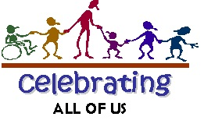

Cultural diversity is all about celebrating the uniqueness of each person. It is about respecting the differences between us and exploring ways to unite rather than divide. It is not about separating ourselves to 'our' specific group. It is about understanding those differences link us to a greater life experience--one that celebrates everyone, fights for social justice, and aims to wipe out the stereotypes that harm and create division. Look at the image above and respond to the following:
- From your viewpoint after reaching the end of this course, why is this an important message to share?
- In what ways does this image create a sense of unity? In what ways does it create a sense of community?
- We strive for cultural diversity within our neighborhoods, our towns and cities, and our workplaces. In what areas are we still lacking? Give examples from your own life experience to support your position.
- In what ways has your understanding of stereotype changed since the beginning of this course?
Click here

Art and Cultural Diversity

You have learned a great deal about how art can be used to educate others on various stereotypes and situations where othering have flourished. Reflect on how this growing awareness has changed your viewpoint on cultural diversity. Locate three images that represent how you see your local community, your regional community, and the world. Next, click on the word "Text" and describe how your viewpoint has changed over the course of the semester. What new awareness has opened up to you? What areas of social justice to you now understand at a deeper level?
Remember to reference the image on the References page.

Music and Cultural Diversity

Music is universal. Every language, every culture, every nation is represented in a song known as the National Anthem. Listen to the anthem representing America and the story it tells of never losing hope that our national flag will continue to fly despite war or hardship.

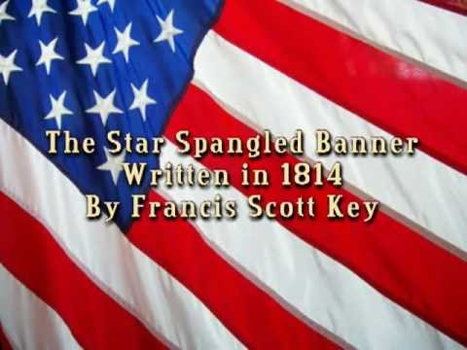
Next, go to YouTube and find a national anthem from another country. It could be a country you have a direct connection with, one that have seen in the news, or one you just find interesting. If it is a non-English speaking country, please select a version that includes the English translation.

Listen to the anthem multiple times so that you can best understand the story the anthem is telling. Once you select your video, share the URL in the textbox below. Be sure to reference the video on the References page.
Click here

Address the following:

1. Explain why you chose this video and in what ways does this nation differ from America?
2. Compare the two anthems in terms of tone and tempo. Is one faster than the other or have a stronger beat? How does this add to the anthem's message?
3. Compare and contrast the two anthems in terms of unity. How do the stories reflected in the lyrics promote the same things? How are they different?
4. In a world moving away from the idea of 'separate' nations, is the role of the national anthem still relevant? Defend your position.

Click here

Cultural Diversity and Literature

The story below reveals the reality that sometimes othering or sexism or other forms of social injustice cause significant damage in a person's life.

Lin's Story

I remember the sting that day brought to my soul. A burning kind of sting that is still sore today. It was early April and my 9th grade class was about to line up to head to the auditorium. Awards day was a big deal to everyone but me. For me it meant more teasing, more rolling eyed glances, more not-belonging.
I had a gift my grandma always said. Not all girls could do what I do with numbers and equations. By 9th grade I could do calculus and differential equations in my sleep. I loved how things fit in mathematics. Every symbol, every integer had a role to play and everything worked together in unison to reach a final answer. If only people worked together this way.
That day started with the usual question from one of the mean kids. 'Hey. When are you moving back to Asia, Math-brat?' That was easier to shrug off than the constant teasing that I was a freak of nature for doing 'boy math.'
I took my seat in the auditorium ignoring the constant kicking against the back of my chair and the barrage of teasing mixed with insults coming at me from every angle. I remember wishing I wasn't smart and hoping my gift would go away. I should have felt proud when Mrs. Jackson, our principal, announced I was the winner of the Achiever in Mathematics award, but it didn't feel like winning. I walked across the stage seeing the angry stares coming from the mean kids. I knew I would never belong as long as I did math.
It was an easy choice really. When I stopped working equations, I had time to hang out and soon the mean kids weren't so mean anymore. I spent my time talking about guys and learning how to use make up. Who needs math anyway?

In the textbox below address the following questions:

1. What stereotypes (there is more than one) do you see demonstrated in this story? How did these connect to your own life experience? Could you relate to Lin's situation in some direct way?
2. Othering can be life altering. Have you ever done something, or in Lin's case, stopped doing something due to peer pressure? Did you regret that decision?

Click here

Reflections

This week you reflected on the key concepts and objectives of this course. Please address the following to complete your Unit 7 template.
1. Revisit Lin's story and think about what her life might have been had she continued her pursuit of mathematics. Create a new story for Lin that describes what her future might have been. Did she go to college? Did she discover some new technology that brought peace and prosperity to the world?
Click here

2. Think about the negative impact of stereotypes or othering in your own life experience and address the following:
- What things have you avoided to avoid not belonging?
- What talents or opportunities have you turned aside to avoid being stereotyped?
- In what ways would you like to see your sense of empowerment restored?
Click here

Reference page
Reference your video or any other sources used here.
Humano773. (2012, October 30). United states of America's National Anthem [Video}. YouTube. https://youtu.be/M1wLtAXDgqg

