The Journey Begins with You!

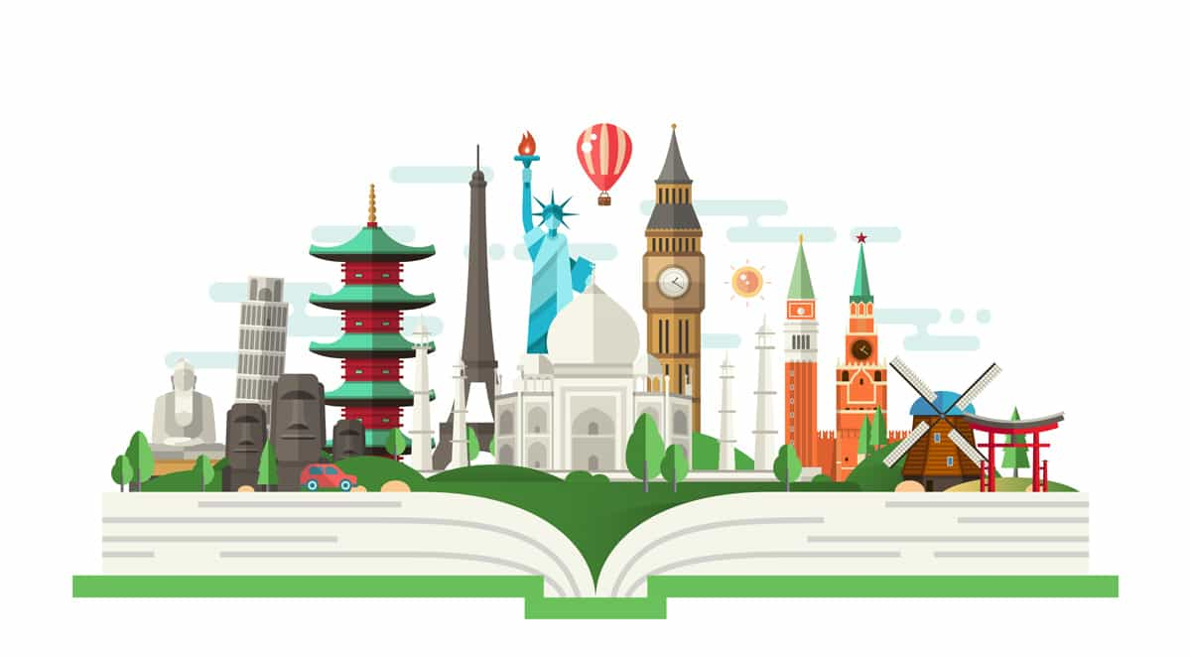

Create a mini bio that explores 'you.' Basic facts are fine as a starting point (where you were born or where do you live) but aim to look at yourself in terms of how others experience 'you.' Here are some questions to consider:
- What important life lesson would you like to pass along to others?
- What can older people (or younger people) learn from your generation?
- What personal achievements make you proud?
Click here to begin your mini bio!

Art as Culture
Click on the picture icon to the right and insert images of art that reflects your culture. Click on the word "Text" and describe how each image represents your culture and explain why you chose it? If necessary, reference the image on the References page.

Music and Dance as Culture
Go to YouTube and search for a video of a dance or musical performance that interests you from any time period or culture. Once you select your video, share the URL in the textbox below. Be sure to reference the video on the References page.

Address the following questions:

1. How does the dance or musical performance reflect the uniqueness of the culture represented?
2. How does the dance or musical performance connect with you?
3. In what ways does it contribute to the idea of universal culture?
Click here

Click on the picture icon below and insert an image that represents your current community.

Click the picture icon below to insert an image of the last book or internet article you read for fun.

In the textbox below, explain the last book or article you read for fun. Did it connect directly or indirectly to your culture? How did this contribute to your understanding of universal culture?

In the textbox below, explain the greatest strength of your community. How might other regions, cities, towns or neighborhoods bring that strength into their own community? Next, explain what weaknesses exist. What areas would you like to see improved?

Click here to respond
Click here to respond

Reflections

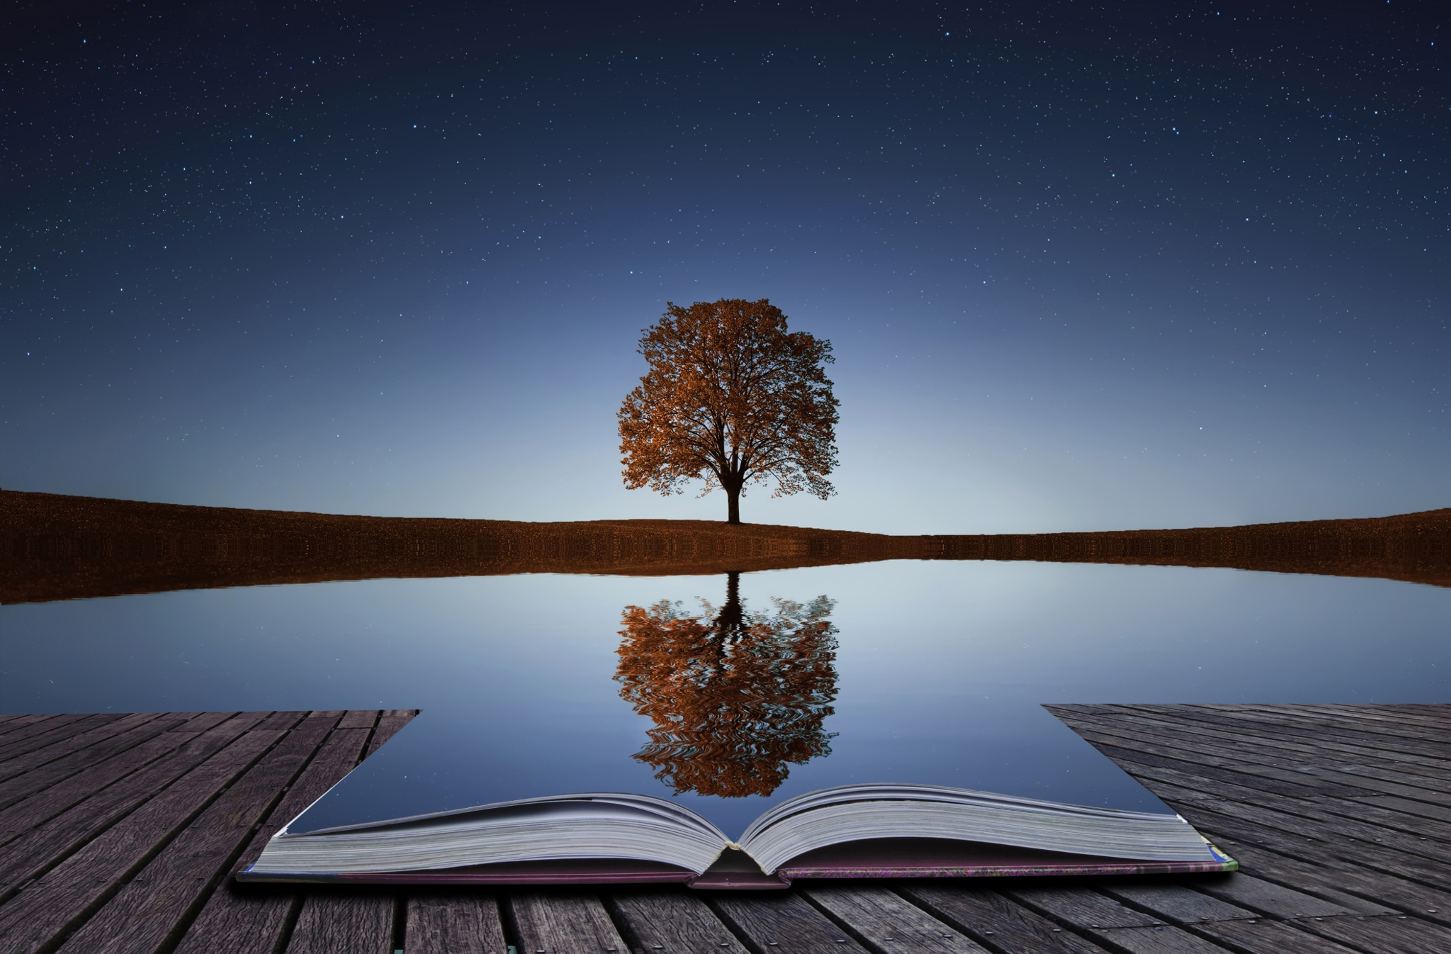
Now that you have had the opportunity to learn more about specific aspects of culture, please address each of the following to complete your Unit 1 template.
1. Were there any key memories from your childhood that helped shape who you are today? (This might include school memories, experiences with friends, family, teachers or mentors. It might include specific values or life lessons that were passed on from the early stages of your life.)
Click here

2. What impact did the media have on your perspective of culture growing up? (This could include books, television, or movies that made an impression on you as a child.)
Click here

3. Have you experienced a defining moment in your life that may have changed your perspective or gave you a new outlook on the idea of cultural diversity? (This could include a time when you experienced 'culture shock' after coming into contact with a culture different from your own; it could come from finding a lost heirloom that made you more aware of your own culture; it could come from meeting someone new who had an impact on you, an experience at work or school that inspired and motivated you to experience the idea of culture in a new way.)
Click here

4. Over the course of this first unit, how has your concept of your own culture changed? Are you more aware of its richness? Do you have a better understanding of the importance of celebrating who you are?
Click here

Reference page
Reference your video or any other sources used here.

