Perspective: The Journey of Narrative

We can learn a great deal about perspective by looking at our life through a new lens. The metaphor is a powerful narrative tool that presents a message indirectly. Choose a metaphor that best represents some aspect of your life and post an image of it in the box above. For example, if your life was full of wrong choices but is now leading you to new success, your metaphor might be the Phoenix. If you were always told you could never learn how to do something, but you learned how to do it well, your metaphor might be the wise owl. If you had a life-threatening illness or accident and fought your way through recovery, your metaphor might be a butterfly who passes through life stages in amazing ways. The possibilities are endless and will uniquely present a new perspective of 'you.'
After you post the image of your metaphor, please address the following:
- Explain your metaphor and why you chose it. Do this in a way that someone who has never met you will be able to connect with your story.
- What new understanding about yourself will this metaphor hold for you moving forward?
- How might understanding your life in terms of this metaphor help you let go of the mistakes or the pain of the past in a deeper way so that you can best engage your future?
Click here

The First Person Narrative Through Art
Frida Kahlo is one of the most famous and prolific self-portrait artists in recent history who chronicled her inner struggles through her paintings. Visit Google Images and search for Frida Kahlo. From the numerous self-portraits, select three, click on each picture icon below and insert their images. Click on the word "Text" and describe the message you feel Frida is sending to the audience about herself or her perspective on life. If necessary, reference the image on the References page.

First Person Narrative in Music
Music of all genres often tell first person narratives directly and indirectly. Go to YouTube and find an autobiographical music video that either reflects the singer's life using direct or figurative language. Select one that you feel has a strong narrative that needs to be told. For example, Amy Winehouse's song, Rehab, shares her struggle to find sobriety. Dolly Parton's, Coat of Many Colors, shares her struggle to understand how others viewed her family's poverty. Melissa Etheridge's song, California, which shares her courageous journey from the Midwest to California to pursue her music.
Once you select your video, share the URL in the textbox below. Be sure to reference the video on the References page.
Click here

Address the following:

1. What video did you select and why?
2. Would an audience be as interested in this story if it wasn't in musical form? Support your position.
3. What imagery in the lyrics connect most with you? Why?
4. Did the song present a life lesson or theme that told a deeper story? Explain what that life lesson or theme was.
Click here

Literature and Identity Power

Previously, we explored how literature has become an effective tool to bring 'voice' to the marginalized and underrepresented. What happens when the writer is marginalized and underrepresented in a way we do not expect? Does the literature have less effect on the reader? The same? More?

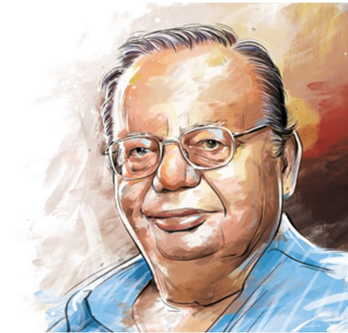

Ruskin Bond was born in Kasauli India and is a prolific, award winning writer. Select the arrow or the video link below and view, The Thief Story.

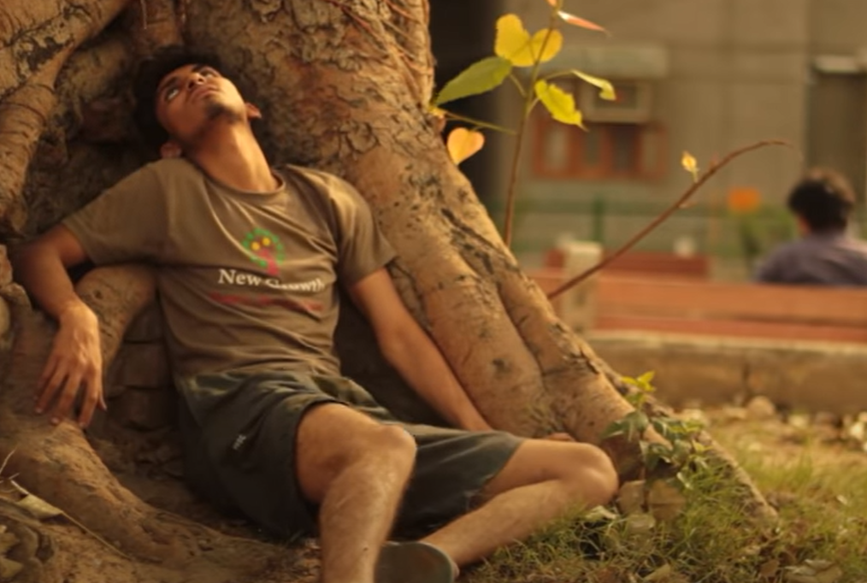
https://youtu.be/HuQbu0TNQ9E
Here is a PDF version of this story: https://ncert.nic.in/ncerts/l/jefp102.pdf

In the textbox below address the following questions:

1. What audience to you think this story is aimed at? Why?
2. How does this story reflect Ruskin Bond's perspective of life in India?
3. Did you notice any stereotypes presented? If so, explain them and why the writer might have used them to tell a deeper story or connect with an audience.
4. What did you notice about his use of figurative language? Did it engage you or cause you to lose interest? Why?

Click here

Reflections

You have explored first person narrative from many perspectives demonstrating the importance of developing your own multi-faceted personal narrative that celebrates all of the things that make you who you are. Please address the following to complete your Unit 4 template.
1. Examine this actual photograph of writer Ruskin Bond. Why do you think there is a discrepancy between the artist's rendition used by his publisher and his actual photograph?
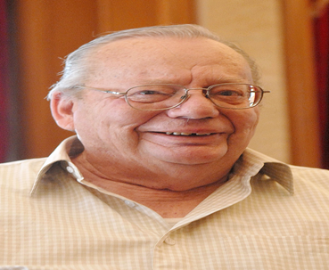
Click here

2. Ruskin Bond was born in India; however, his parents were both of British descent. How does this impact his standing with both an Indian audience and a non-Indian audience? Does this make him an outsider to both groups? Does this make his perspective of Indian life and culture more or less powerful? Defend your position.
Click here

Reference page
Reference your video or any other sources used here.
Shivangi Jain. (2014, Jun 7). The Thief – Ruskin Bond NCERT short 10 [Video]. YouTube. https://youtu.be/HuQbu0TNQ9E

