Community, Art, and Identity

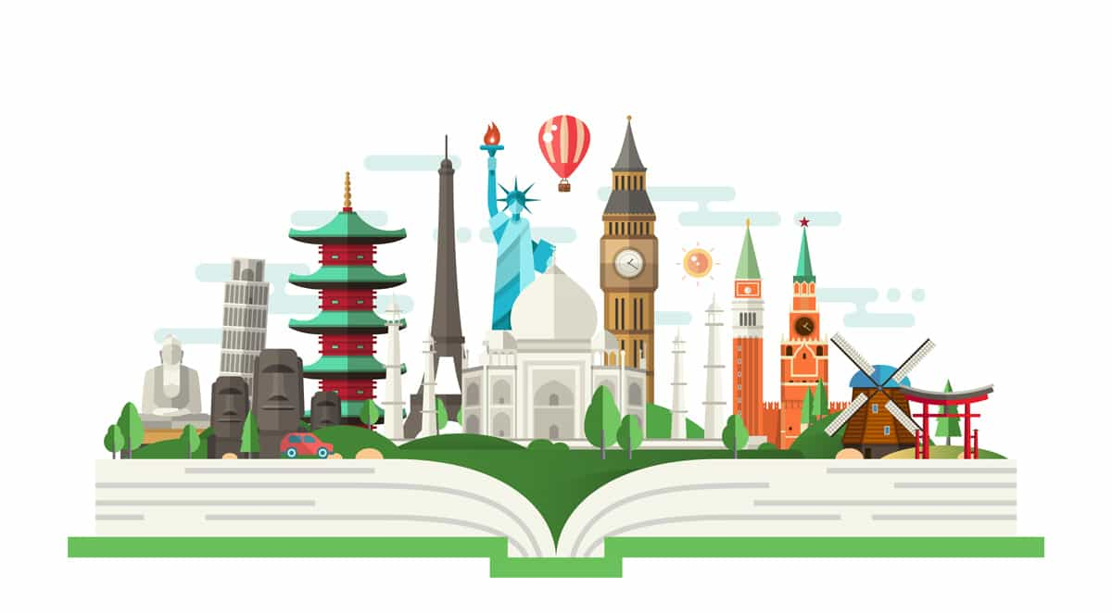

The people of Herzing University (Atlanta Campus featured above) makes up a rich and thriving community. This piece of visual art is something current students as well as potential students see in social media and when searching the website giving it power to build community by creating a sense of welcome. Examine the picture above and consider how it represents the 'Identity' of Herzing University and address the following:
- In what ways does this image create a sense of welcoming?
- In what ways does this image reflect the reality of achieving your academic goals through hard work?
- Does this image help you to embrace a new sense of empowerment for as you become a part of the Herzing University community?
Click here

Community and Identity Through Art
Your local community is another place where you can celebrate who you are and how you contribute to society. Visit either a local newspaper website or the nearest large city newspaper to you. Go to their community page and locate three 'positive' images that demonstrate community in your area. Click on the word "Text" and describe the ways each image empowers your sense of community and identity. (How does this image project an "I am proud to live here" type of atmosphere). Would this image encourage others to join your community? Why? Remember to reference the image on the References page.

Community and Identity in Music
Music of all genres often tell personal stories of identity as well as broader narratives of community. For example, Lee Greenwood's classic song, "I'm proud to be an American" demonstrates the feeling all Americans share about the opportunities they have received to build strong families and strong communities.
Go to YouTube and find a dance or musical performance that reflects your sense of community (that can be local, regional, or your Herzing community) and/or your sense of identity.
Once you select your video, share the URL in the textbox below. Be sure to reference the video on the References page.
Click here

Address the following:

1. What video did you select and why?
2. Would an audience understand the connection between the performance (or song lyrics) and the ideas of community or identity if it wasn't in musical form? Support your position.
3. What imagery in the performance or the lyrics connect most with you? Why?
4. What did the performance contribute to your understanding of community building and/or identity awareness?
Click here

Literature and Community

Literature is a powerful artform known for its ability to explore unique perspectives of historical eras that reflects and celebrates community in its many forms. Literature can also reflect on the destruction or loss of community. Leslie Marmon Silko is an example of how identity and community are linked into an unbreakable bond. Like the writer Ruskin Bond from the Unit 4 portfolio, Leslie Marmon Silko is of Native American descent, but she is equally Mexican American and Anglo American. Her unique tri-racial heritage produced a wealth of unique perspective. Visit this website and read her poem, Story From Bear Country.

In the textbox below address the following questions:

1. What figurative language does Silko use in the first three stanzas to establish community in her story?
2. How does stanza four reflect a turning away from that community?
3. What are the 'Bear Priests' in terms of the community? Why do they pursue those who turned away?
4. In what ways do you relate to this type of loss of community?
5. In your view, what is the last stanza saying to you directly and to the world at large?

Click here

Reflections

You have explored community, art, and identity in empowering ways this week. Please address the following to complete your Unit 5 template.
1. Select one area of the arts (music, dance, performance/theater, literature, sculpture, painting, etc.) and create a short letter convincing local leaders to provide funding for a specific event showcasing that artform to the public. Explain why that expression of the arts is important to community building and how it will serve to best present local identity to the greater world sat large.
Click here

2. What is the one most empowering thing you learned or celebrated in this segment of the portfolio? How did it connect you to the larger sense of community we all are an important part of in our day-to-day lives?
Click here

Reference page
Reference your video or any other sources used here.
Silko, Leslie Marmon. (2015, Jul 7). Story From Bear Country. Wordpress. https://poetrying.wordpress.com/2015/07/07/story-from-bear-country-leslie-marmon-silko/

