Diversity in the Workplace

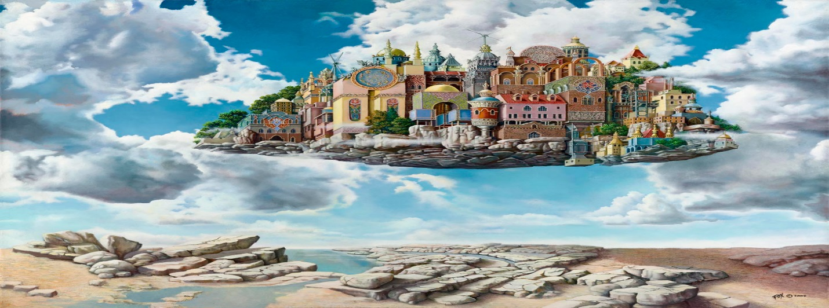
Welcome to the year 2332 where America's space exploration has paid off in the discovery of a strange new world run by an artificial intelligence agent named Mott whose only power source is set to expire in 90 days. Your mission is to persuade Mott not to power up a replacement but to instead hire you and your team of highly qualified specialists to become the workforce. Please consider/address the following:
- Explain to Mott what humanity is at its very core. What values do we share when we get past the issues that aim to divide us?
- Mott has been monitoring earth for eons and knows the problems of in-fighting among us. Make a case to Mott that your crew would not fall into stereotypes, othering, bullying or the other 'human' tools we use to create dis-unity.
- Demonstrate how bringing in a human touch would bring positive elements to their world. (What do we have that Artificial Intelligence does not?)
- What types of negatives will overtake their world should they choose to remain non-human?
Click here

Workplace Diversity Through Art
Mott has a database filled with artwork made by human hands but is unable to understand how artwork could enhance work performance. Search the Internet for three pieces of art that in your view best demonstrates the unity of diversity of the workplace you will create. You can select paintings, sculptures pictures, or any other visual representation of art. Once you find them, click on the word "Text" and explain to Mott how each contributes to humanity's immense creative power that will provide stability in a diverse workplace.
Remember to reference the images on the References page.

Workplace Diversity through Music
Mott does not see music as something that calms the nerves, soothes the soul, and brings joy to the listener. Mott sees it only as a tool of division and distraction for humans preferring you and your team to work in silence.
Go to YouTube and find a musical performance that demonstrates the universal power of music to bring people of diverse backgrounds together. For example, your selection could represent multiple groups that represent human unity at its best such as the 1985 iconic song, We are the World. It can be something soothing like a meditation melody, a tune that needs a full symphony to present or a single voice, or it could be a patriotic song that establishes our common ground.
Once you select your video, share the URL in the textbox below. Be sure to reference the video on the References page.
Click here

In the textbox below, make a case to support the power of music to unite the workplace.
Click here

Literature and Diversity in the Workplace

There are many forms of literature including laws or Legislative Acts. Revisit your Learning Content for Unit 6, explain why it is important for Mott to stop excluding humans from the workplace. Use specific points from Unit 6 to establish the need for change from a completely Artificial Intelligence society to one benefiting from the creativity and insights humanity can contribute.

Click here

Reflections

The week you took a look at diversity from a different and unique perspective. Please address the following to complete the Unit 6 template.
1. While our fictional character, Mott, symbolizes technology in its most developed form, describe living in a world that is void of human negatives. What would it be like? How would that impact the human spirit? Would there be benefits?
Click here

2. The workplace is often where diversity is celebrated. Describe your workplace in terms of diversity. What are its strengths? Weaknesses? Is change needed? If so, in what areas? If you are not currently working, describe an ideal workplace in terms of diversity.
Click here

Reference page
Reference your video or any other sources used here.

