Name Click here to enter text.
Course and Section Number Click here to enter text.
Date Click here to enter a date.

PD 202 Unit 5 Network Mind Map Activity

Instructions:
As discussed in Unit 5, approximately 85% of jobs are filled using networking. There are many ways you can organize your network. One way is through the use of a network mind map. The mind map presented here is a basic one that begins with six (6) current contacts. To expand your network, brainstorm two (2) additional contacts you might be able to make through each of those first six. Complete this Network Mind Map (on the next page) by adding names for contacts or organizations that you can use to build your network in each of the boxes. Your finished mind map will have 18 potential contacts you could use to find and get a job.
Once you have completed the mind map, reflect on the experience by answering the following:
- Of the original six (6) contacts:
  - How many were relatives? Click here to enter text.
  - How many were friends? Click here to enter text.
  - How many were business acquaintances? Click here to enter text.
- Which types of original contacts would be most helpful in finding job opportunities (if any) and why? Click here to enter text.
- How difficult was it for you to expand your network by adding two (2) secondary contact to each of the original six (6)? Click here to enter text.

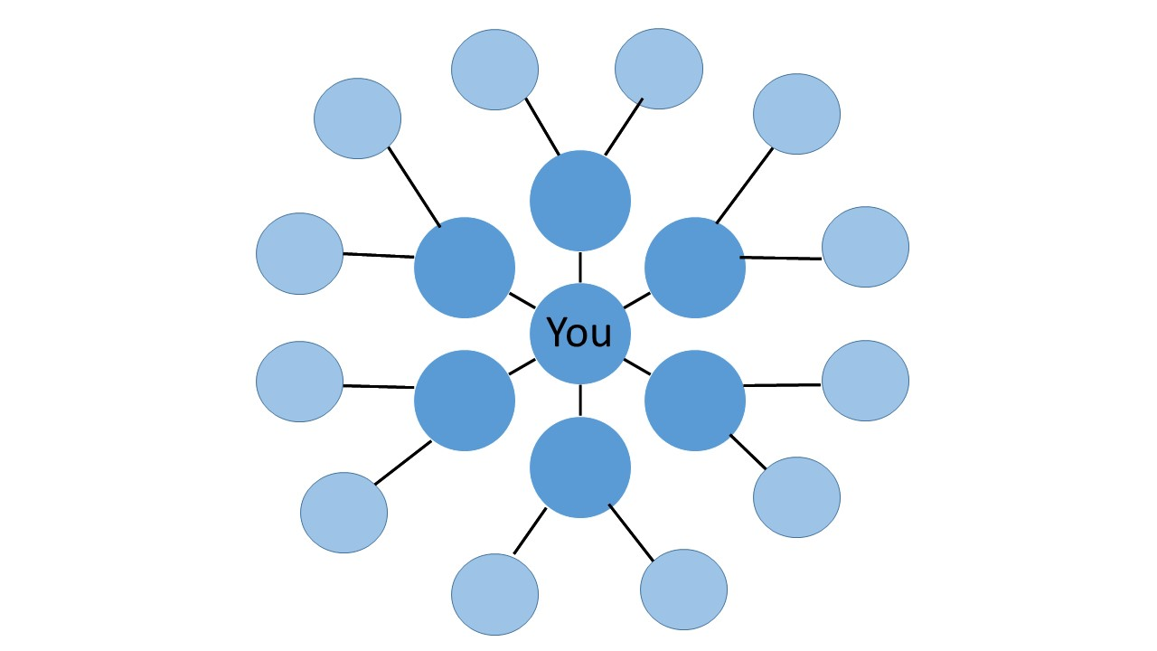
Click here to enter text.
Click here to enter text.

Click here to enter text.
Click here to enter text.
Click here to enter text.
Click here to enter text.
Click here to enter text.
Click here to enter text.
Click here to enter text.
Click here to enter text.
Click here to enter text.
Click here to enter text.
Click here to enter text.
Click here to enter text.
Click here to enter text.
Click here to enter text.
Click here to enter text.
Click here to enter text.

