Career Center Interview Simulation Trainer

The Interview Simulation Trainer is an outstanding tool for students to practice responding to interview questions, record answers, and review each answer in real time. Career Development coaches can also review responses and provide feedback. In addition, like many of the Career Center tools, users can access informative coaching videos which are available on each interview question.

To get started, be sure to have a working webcam to access the Interview Simulation Trainer.

- Login to Canvas and open the Career Center
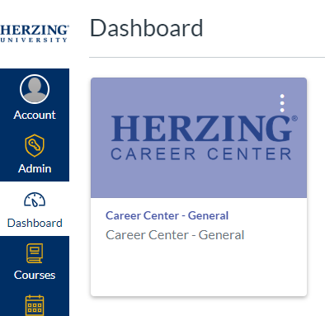

- In the Career Center, click on the Toolkit in the left navigation, then select the Interview Simulation Trainer icon

- Or, access the Toolkit through any of the modules on the bottom right of the page, and select Interview Simulation Trainer

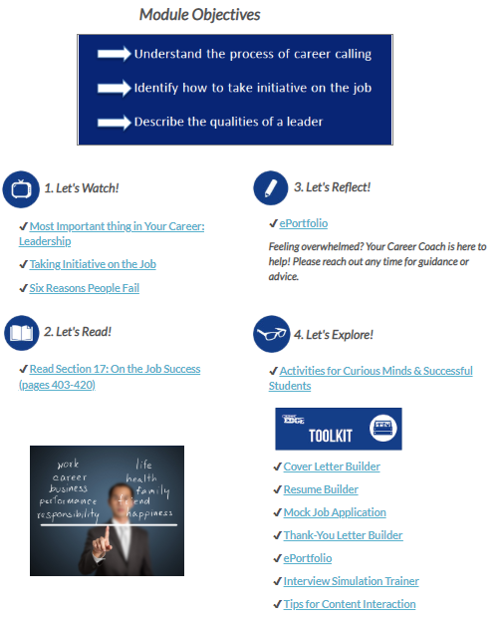

- Once in the Interview Simulation Trainer, watch the overview video for tips on interviewing effectively.
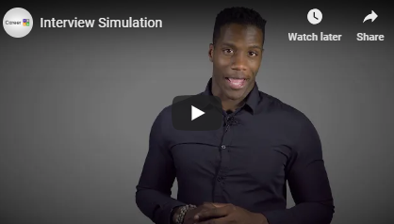

- To access the video questions, enter a name for an interview simulation on the right such as an upcoming interview to practice for with that company’s name. Then click Start New Interview

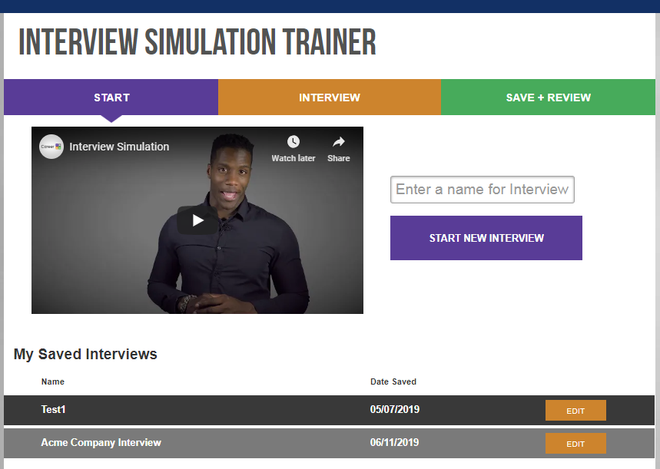

- Review the list of interview questions and select all or several to practice:

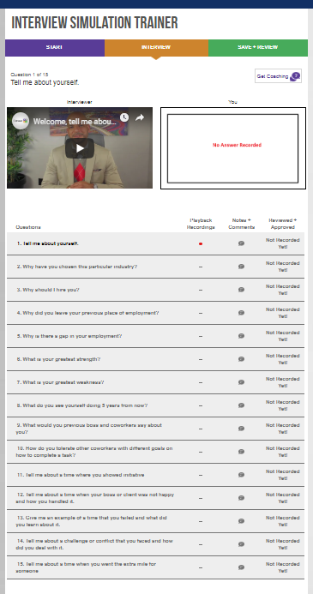

Receive coaching on specific questions by clicking on the Get Coaching button

Click on the interviewer to hear the selected question

Record the answer to each question

Select questions from the list to work on and answer

Add your own notes and comments

Track which questions have recorded answers

- Finally, be certain to reach out to your career development coach and ask for feedback on your recorded questions. His/her comments will show up in the Notes + Comments

